Practical No. 03

Setup a WAN which contains wired as well as wireless LAN by using a packet tracer tool. Demonstrate transfer of a packet from LAN 1 (wired LAN) to LAN2 (Wireless LAN).
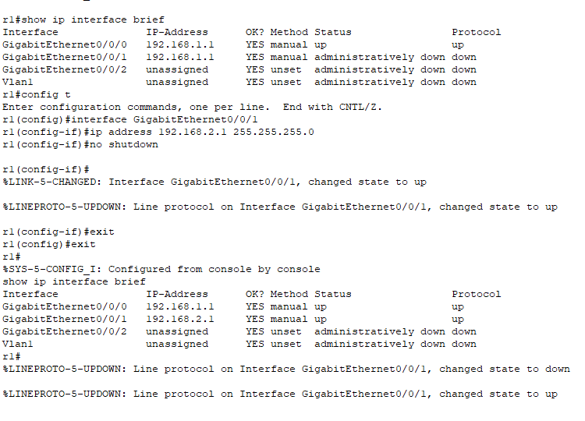

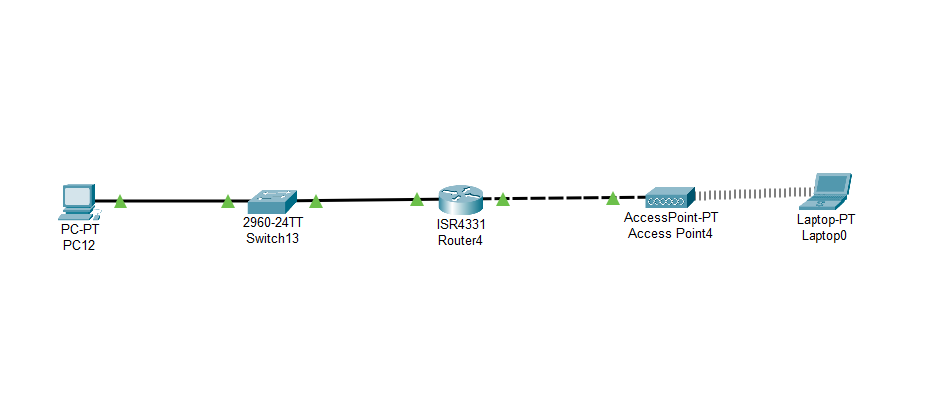

Practical No. 11

Installing and configuring DHCP server and assign IP addresses to client machines using DHCP server.

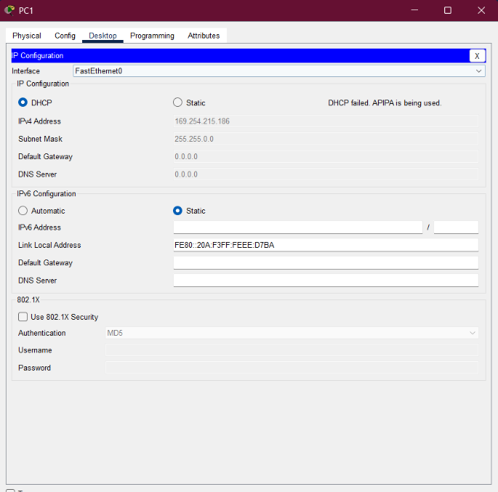
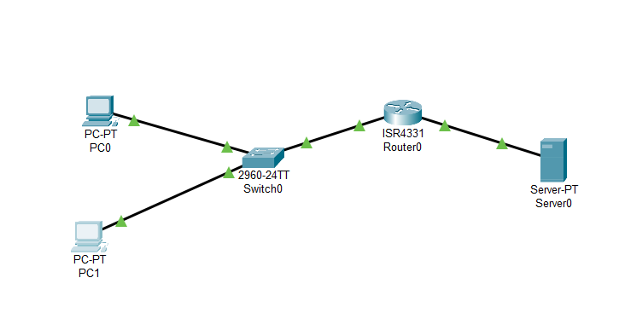
Output:-
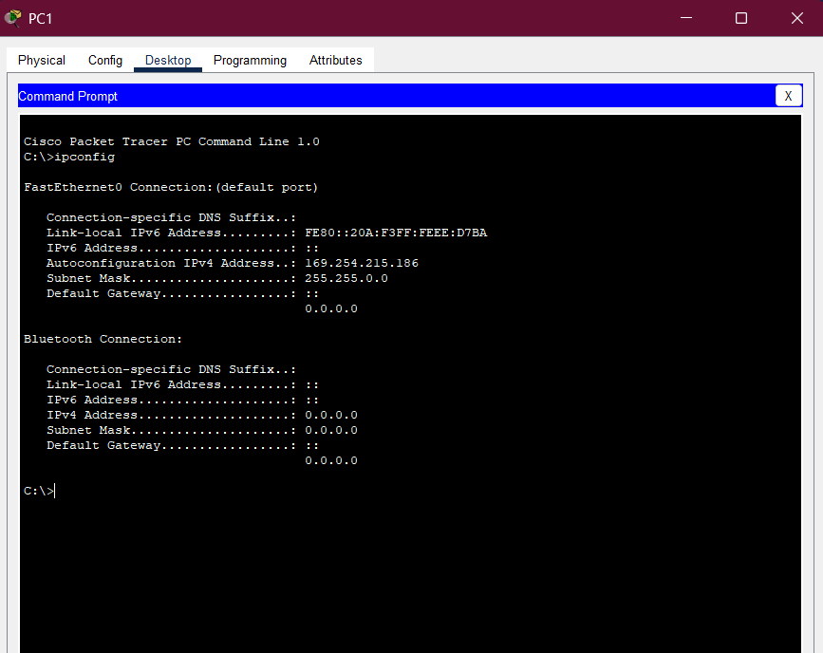

Practical No. 12
Write a program for DNS lookup. Given an IP address input, it should return URL and vice versa.

Program:

import java.net.*;
import java.util.Scanner;

public class DNSLookup {
public static void main(String[] args) {
Scanner sc = new Scanner(System.in);
System.out.println("Mr.AB");
System.out.println("Enter '1' for Domain to IP lookup");
System.out.println("Enter '2' for IP to Domain lookup");
System.out.print("Your choice: ");
int choice = sc.nextInt();
sc.nextLine(); // consume newline

try {
if (choice == 1) {
System.out.print("Enter domain name (e.g., www.google.com): ");
String domain = sc.nextLine();
InetAddress ip = InetAddress.getByName(domain);
System.out.println("IP Address: " + ip.getHostAddress());
}
else if (choice == 2) {
System.out.print("Enter IP address (e.g., 142.250.183.36): ");
String ipStr = sc.nextLine();
InetAddress addr = InetAddress.getByName(ipStr);
System.out.println("Host Name: " + addr.getHostName());
}
else {
System.out.println("Invalid choice!");
}
}
catch (UnknownHostException e) {
System.out.println("Unable to resolve host/IP: " + e.getMessage());
}

sc.close();
}
}

Output:-
